# **Notice of data processing program**

To run the data processing program, you first need a python environment, here we will use Anaconda. When you open your python IDE, here Spyder, you just must open  the file downloaded on my GitHub named “Traitement_donnée_to_csv.py“.

then You run it with F5 or the run Bottom 

When it is launched, you are asked to give the path of the file to be processed.



Attention /!\ if you enter an absolute path with "/", it will be necessary to double the "/" (Example: "C://user//username"), or if you enter an absolute path with "\", it will be necessary to put the letter "r" before the path.

(Example: r"C:\user\username").

After this, the program will ask you if you want to create a pict of a camembert 

Tap 1 if your answer is YES, or 2 if NOT

At the end of the process, you will find an excel file created near your file path .

**For exemple :** 

and a pict of the camembert if you realize it.

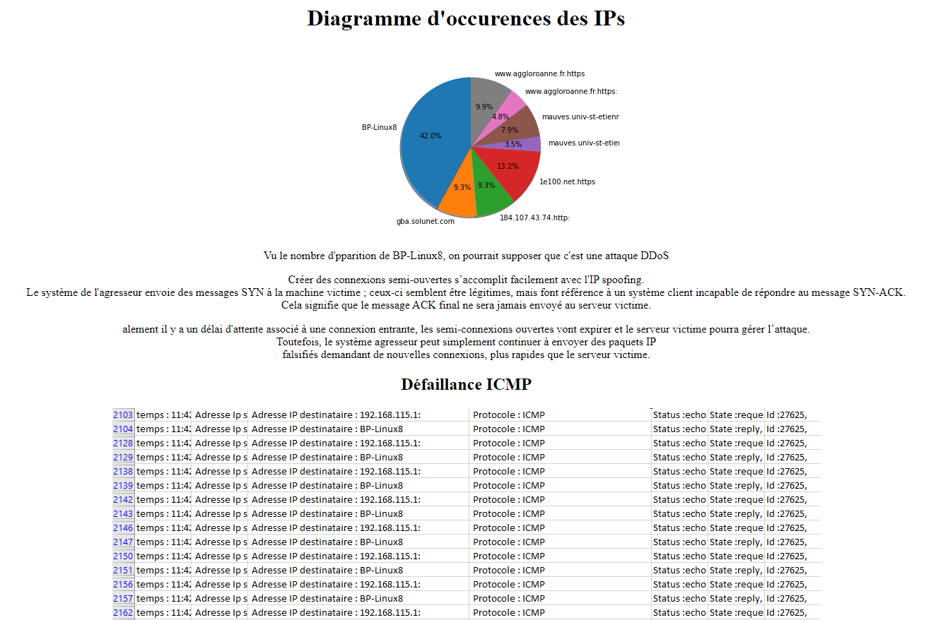finally, an html file named "page_defaillance.html" was created when you accepted the creation of the camembert. It is instantly executable.